CSCI 5010 – Fundamentals of Data Communications

Lab 4 – VLANs, trunking and

inter-VLAN routing

University of Colorado Boulder

Department of Computer Science

Network Engineering

Professor Levi Perigo, Ph.D.

# Summary

The foundational layer to any network revolves around switching. This lab is intended to be an overview of VLANs, trunk links and inter-VLAN routing.

The questions in the lab are intentionally vague. The purpose of this is for you not only to research, investigate, and learn the technologies, but also become proficient at interpreting both non-technical and technical questions. Being able to research and discover answers on your own will be critical as you progress in your career.

* Learn how to create VLANs within a single switch
* Learn how to create VLANs across multiple switches
* Learn how to achieve Inter-VLAN communication using trunking (802.1q) and “routing on a stick”

# Objective 1 - Switch VLAN Configuration

This objective will configure multiple VLANs on a single switch.

Diagram 1

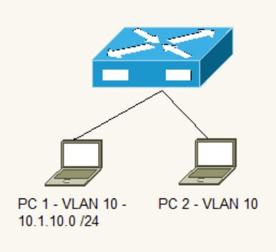

Diagram 2

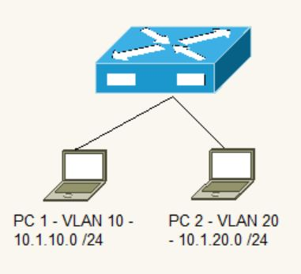

1. Use diagram 1 to verify connectivity within same VLAN (VLAN 10)
2. Assign IP addresses to the PCs
   1. Make sure the PCs are in the same subnet
   2. What are the IPs you assigned to both PCs? Why do these IP subnets have to be in the same subnet? **[5 points]**

192.168.1.0/24

PC1-192.168.1.2

PC2-192.168.1.3

These IP subnets must be in the same subnets because in order to communicate with each other they need to be in the same network. The highest layer of communication is L2, which is from the means of a switch.

* 1. Verify Ping connectivity between PCs. Paste screenshot **[2 points]**

1. Now create two different VLANs (diagram 2)
   1. VLAN 10 should be named Engineering
   2. VLAN 20 should be named Sales
      1. Use the appropriate **show** commands on the switch to indicate this [**5 points**]

1. Assign PC1 to Engineering
2. Assign PC2 to Sales
   1. Assume no MAC entries exist in the switch. Explain step by step everything that happens in the network as soon as ping is initiated from PC1 towards PC2. Can PC1 ping PC2? Why or why not? [**10 points**]

When a ping is initiated from PC1 to PC2, it sends a broadcast over the network that it is in to see if that IP is in its network. Because no MAC entries exist, it will do this, and the switch will store this in the MAC table. They cannot ping each other because they are in different VLANS or networks and there is no L3 device to route the traffic.

1. Enable Telnet on the switch
   1. What should be done so PC1 can Telnet to the switch? [**5 points**]

Conf t

Line vty 0 15

Transport input telnet

Login local

Password password

Login

These are the commands above to configure telnet on the switch. Now the PC can telnet to the switch with the given password.

# Objective 2 - Switch VLAN and Trunk Configuration

This objective will configure multiple VLANs on multiple switches and connect the switches via trunk ports.

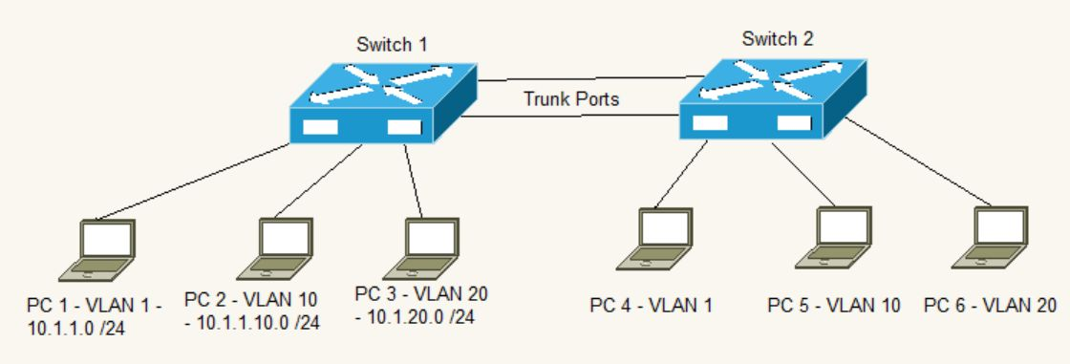

1. Setup the network as indicated in the diagram (*hint: Switch2 configuration should be a duplicate of Switch1*)
2. In what IP subnet is IP address of PC5 present? What design considerations did you have to make when choosing this IP subnet? **[3 points]**

PC5 is present in the 10.1.10.0/24 subnet. Because VLAN 10 is a network and the network is displayed in diagram under PC2, PC5 must be in the same network if it is in the same VLAN. So, PC5 could have an IP address of 10.1.10.3 for example.

1. Can PC1 and PC2 Ping each other? Why or why not? [**3 points**]

They cannot because they are not in the same network.

1. Can PC2 and PC3 Ping each other? Why or why not? [**3 points**]

They cannot because they are not in the same network.

1. Configure the switches so PCs can ping within the same VLAN.
   1. Provide the relevant configuration from both switches [**5 points**]

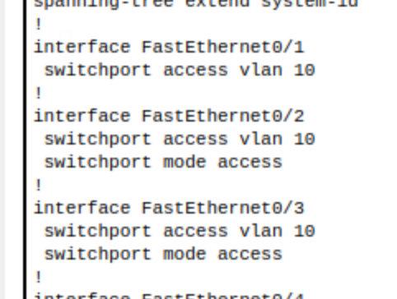

Both switches have the same configuration. To enable the possibility of all the PCs to ping each other, I simply put all of them in the same VLAN. Given they have the right IP addressing scheme, they can ping each other.

1. Explain what must be done to allow all PCs to Ping each other [**10 points**]

To allow all the PCs to ping each other, they must be in the same network. So, following my configuration above, vlan 10 has a network of: 10.1.1.0/24. That means that all the PCs must have an ip in this subnet. Once I configure all the PCs with an ip within that range and a mask of 255.255.255.0, then they can ping each other.

# Objective 3 – Inter-VLAN Routing “Router on a Stick”

This objective will configure multiple VLANs on a switch, and uplink the switch to a router via a trunk port and we will use this router to route between VLANs. Since the router is using one physical port to route incoming and outgoing traffic, we call it “Router on a Stick”

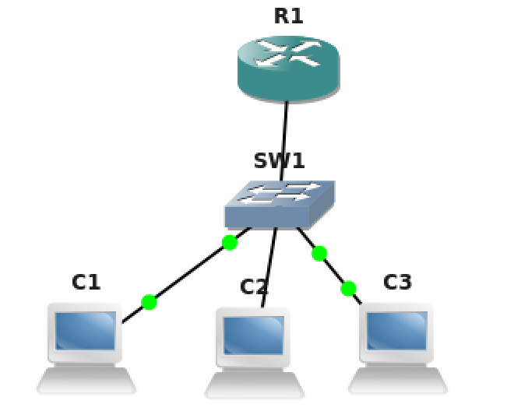

PC1- VLAN**1** –

10.1.1.0/24

PC3- VLAN**20** –

10.1.20.0/24

PC2- VLAN**10** –

10.1.10.0/24

1. What are sub-interfaces on a router? What are its advantages? **[2 points]**

Sub interfaces on a router are logical networks that are connected by one physical connection. It’s useful for having multiple VLANs on a network and allows them to communicate with each other.

1. Configure VLAN sub-interfaces on the router (VLAN1 “native”, VLAN 10, and VLAN 20).
   1. Submit the router configuration that indicates the trunking setup.

[**10 points**]

1. Verify all PCs can Ping each other.
   1. Paste screenshots of trace route from the PC to indicate the packets are traversing through the router for inter-VLAN communication. [**5 points**]

# Objective 4 – Inter-VLAN Routing 2: Multiple switches

This objective will configure multiple VLANs on multiple switches and use a router to route between VLANs.

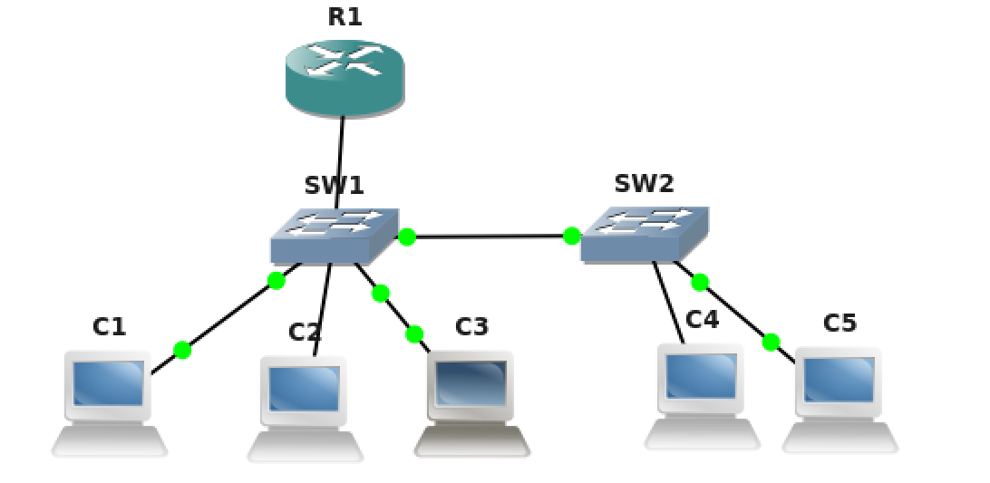

PC1- VLAN**1** –

10.1.1.0/24

PC3- VLAN**20** –

10.1.20.0/24

PC5- VLAN**40** –

10.1.40.0/24

PC4- VLAN**20** –

IP subnet-?

PC2- VLAN**10** –

10.1.10.0/24

1. Look at the above diagram. What is the type of port you should configure between the two switches? (Eg: access port **or** trunk port **or** routed port **or** any other port?)

Why do you have to use this port type? Justify. **[3 points]**

I would configure a trunk port. A trunk port allows traffic from multiple VLANs to flow, if it was a access port, then traffic could only flow between one network.

2. At the end of this lab objective all hosts must be able to ping each other. From your previous setup, you added Switch2 and hosts PC4 and PC5. What extra configurations did you have to add to this setup to establish connectivity between all hosts? Mention each device you had to configure or make changes to achieve this. Just mention snippets of extra configuration you had to add on each device you configured. Also attach screenshot of successful pings and traceroute from PC2 to PC5.

**[15 points]**

The extra configurations I had to make were: configure SW2 with VLAN 20 and 40, and connect them accordingly to the PCs. On the router, I made a sub int 0/0/1.40 with associated network information. I connected a trunk port from SW1 to SW2. All of this allows for communication between every PC.

Report Questions [23 pts]

1. What are two advantages of using VLANs? [**2 points**]

Easier network administration to determine what types of devices are on what types of networks.

Load balancing: Allows for certain services or applications to be designated to one network, allowing for other networks to have their own bandwidth.

1. Can a PC from any VLAN telnet into a switch? Why or why not? If not, what must be done to make it work? [**2 points**]

They cannot as telnet allows access from only the management VLAN. To make this work, we must configure an access control list with the allowed networks/VLANS. Then this will allow any network on the acess list to telnet into the device.

1. What are access ports and what are trunk ports? Explain the difference **[3 points]**

An access port allows for two devices to communicate with each other. A trunk port allows for multiple devices on multiple networks to communicate with each other. One handles device to device communication and the other handles multiple network intercommunication.

1. What is the benefit of using a trunk port? [**2 points**]

The benefit of using a trunk port allows for multiple VLANs to communicate with each other.

1. Describe what must be done to route between VLANs. [**2 points**]

The main thing that must be done to route between VLANs is have a router ‘on a stick’ that has sub interfaces with the VLANs network. This will allow for the router to communicate between the VLANs.

1. In Objective 4, let us say you issued a ping from PC2 to PC5. Explain how the ping packets flow through the network, paying attention to each step when switches forward the packet and routers route the packet. If necessary, mention any ARPs that may need to be issued to establish this communication.

**[12 points]**

PC2 will send a broadcast to its network with its vlan tagged to the ping packet. It will arrive at the switch and basically ask the switch if this IP is in the network, in which it will send it to the router or default gateway address. The router will see the vlan tag to it and route it to the network with the VLAN. This will then get broadcasted down to SW1 and will do an ARP to get the MAC associated with the IP and VLAN. We will see it is not on SW1 and will go to SW2 with another ARP to get PC5.

Extra Credit [13 points]

1. What is a broadcast domain? How many broadcast domains are there in the topology in Objective 4? **[3 points]**

A broadcast domain is a logical division of a network that shows what devices are in that network and can communicate with each other by broadcasting the same network. There are 4 broadcast domains

# 2. From your setup in objective 4,

# On Switch-1 port (connected to Switch-2), configure VLAN 10 as native-vlan.

# On Switch-2 port (connected to Switch-1), configure VLAN 20 as native-vlan.

Give it a minute. Do you observe any debug/warning messages on either of your switches? If yes, paste the message here. **[8 points]**



To your best knowledge, explain what you think it means **[2 points]**

To my best knowledge, I think if the native VLANs are different then if no VLANs are configured, communication relies on the native VLAN and then these 2 swtiches could not communicate anymore.

# Total Score = ________________/122